EM Basic - Neonatal Resuscitation Program (NRP)
Authors: Azif Safarulla MD, Jessica Gancar MD, George Hsu MD, Daniel McCollum MD.
©2019 EM Basic LLC, Steve Carroll DO, and the authors above. May freely distribute with proper attribution

Scenario
- Pregnant mother in labor and en route to ER
- Delivery is imminent

Approach

Multidisciplinary team approach – ER, OB and NICU teams. Timely notification of other teams is key.
Know your setting in terms of resources, pediatric tertiary care centers, distances and mode of transport available if needed.

Initial Questions – Allows team to prepare appropriately
- One baby or multiple so as to decide on number of personnel needed for stabilization.
- Term or preterm, equipment chosen will vary depending on gestational age (GA)
- Relevant maternal serology
- Rupture of membranes? If yes, is fluid clear, bloody or meconium stained.

Key difference in NRP: Ventilation is key. Still follows airway (A), breathing (B), circulation (C) sequence compared to C-A-B sequence in PALS and ACLS.

IMPORTANT STEPS – Prepare for the worst case scenario

- Initial Stabilization – Thermoregulation
- Warmer which is turned ON (Normal temperature is 36.5 to 37.5⁰C)
- Warm towels and hat (Neonates have high surface area and lose heat rapidly)
- Neowrap (for <32 week GA)
- Transwarmer

- Airway – Open airway and Clear secretions
- Shoulder roll to open up airway and maintain sniffing position
- 8 – 10 Fr Suction catheter set to 80 to 100 mm Hg negative pressure
- Bulb suction

- Breathing – Provide ventilatory support
- Self-inflating bag or T piece resuscitator, set at PEEP of 5 and Peak inspiratory pressure of 20 cms of H₂O, adjust flow rate to 10 LPM.
- Mask (Appropriately sized to cover mouth and nose)
- Set FiO2, 21% for ≥ 35 week and 21 - 30% for <35 week
- Orogastric tube to decompress abdomen
- Endotracheal tube – 2.5, 3.0, 3.5 size
- Blade – Miller 00, 0 or 1
- CO2 detector
- Pulse ox probe (Applied to right wrist for preductal saturations)
- EKG leads

- Circulation – Hemodynamic support
- Umbilical venous catheter – 3.5 or 5 Fr
- Insertion kit – cord tie, scalpel, forceps
- Epinephrine (1:10000 concentration)
- Normal saline

- Miscellaneous
- Pre resuscitation briefing
- Assign roles to team members
- Team Include – Leader, Respiratory therapist, Auscultator (HR and breath sounds), Compressor, Line insertor, Meds, Recorder
- Closed Loop Communication

Once Baby is delivered, initial questions to be asked
- Appears Term/Preterm
- Respiratory effort – Crying/gasping/none
- Tone – Flexor (good) / extensor (bad)

Ventilation is KEY. Airway – Breathing – Circulation sequence

Objective measure of success of resuscitation - Heart Rate

Heart Rate targets
- ≥ 100 bpm - Resuscitation going well
- ≥60 and <100 bpm – needs positive pressure ventilation
- < 60 bpm – Needs Chest compressions in addition

Time intervals for monitoring Heart rate
- Every 30 seconds
- Extends to 60 seconds when chest compressions ensue

Targets for Oxygen Saturation (Preductal)
- 60% within the 1st minute of life
- Takes around 10 minutes to reach 90 – 95% sats

Corrective measures for improving ventilation
- M Adjust Mask to cover mouth and nose
- R Reposition airway
- S Suction mouth then nose
- O Open mouth
- P Pressure increase
- A Alternate Airway

If HR < 60 bpm, Compressions start
- Compressions and breaths coordinated at 3:1 ratio

Intravenous access – Umbilical venous catheter
- Think about placement once compressions started
- Clean and not sterile procedure
- Insert catheter till blood return obtained (around 4-5cm)
- Drugs given – Epinephrine, normal saline and dextrose
- Dose of epinephrine – 0.1 ml/kg for IV and 1ml/kg via endotracheal route.

Debrief
- VERY IMPORTANT, only way to get feedback and improve.

References:

- American Academy of Pediatrics and American Heart Association. Textbook of Neonatal Resuscitation (NRP). 7th ed. Chicago, IL: American Academy of Pediatrics (2016)
- Ringer SA, Aziz K. Neonatal stabilization and postresuscitation care. Clin Perinatol. 2012;39:901–183.
- Perlman J, Kattwinkel J, Wyllie J, Guinsburg R. Velaphi S; Nalini Singhal for the Neonatal ILCOR Task Force Group. Neonatal resuscitation: In pursuit of evidence gaps in knowledge. Resuscitation. 2012;83:545–50
- Kamlin CO, O’Donnell CP, Davis PG, Morley CJ. Oxygen saturation in healthy infants immediately after birth. J Pediatr. 2006;148:585–9
- Remick, K., Gausche-Hill, M., Joseph, M.M. et al, Pediatric readiness in the emergency department. J Emerg Nurs. 2019;45:e3–e18
- Cincinnati Children’s Hospital UVC Placement on Sim Newbie

(Contact: steve@embasic.org)

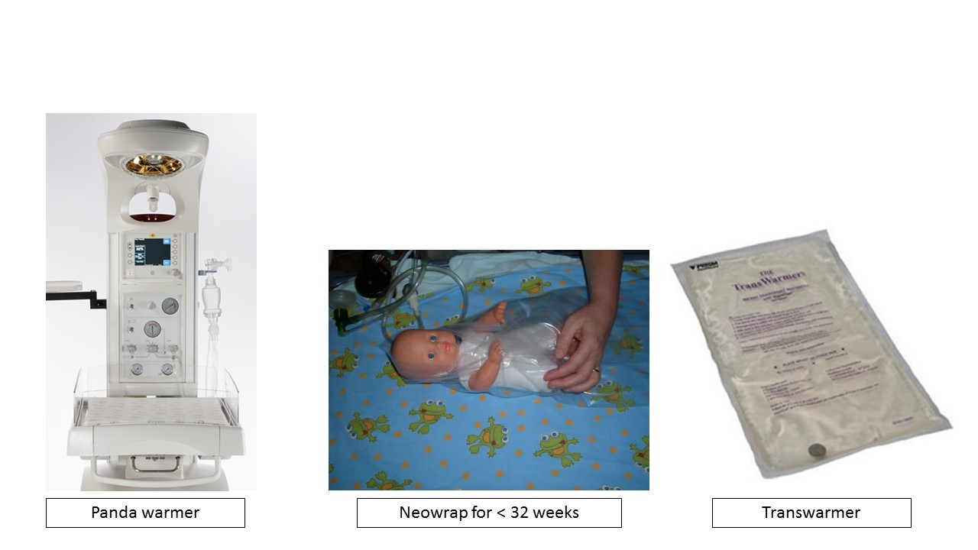
Thermoregulation

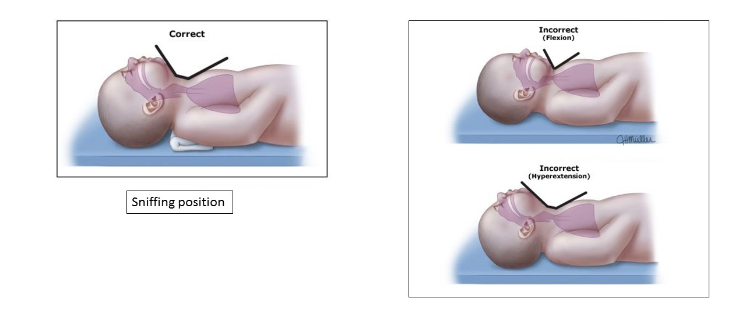
Sniffing Position

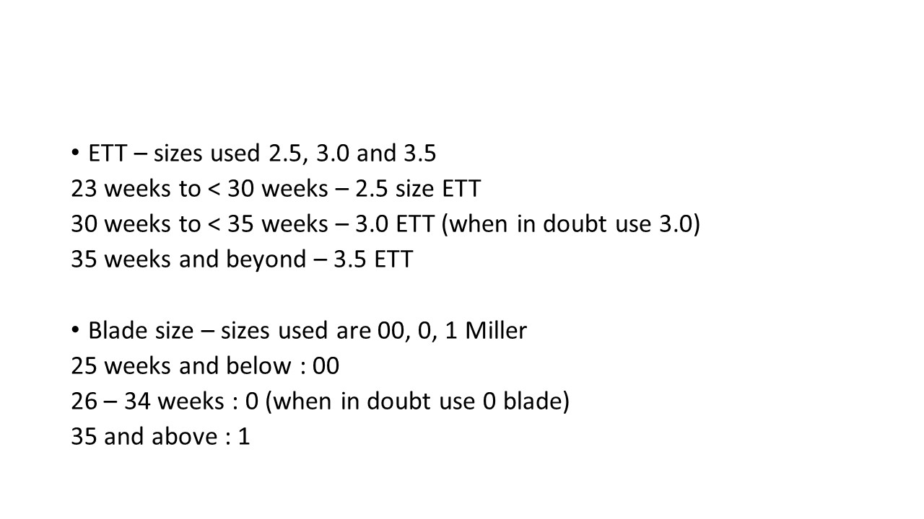
Endotracheal tube and Blade size

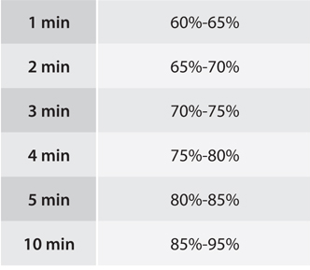

Target Oxygen Saturations

