EM Basic- The Undifferentiated Sick Infant
by Dr. Tim Horeczko
(This document doesn’t reflect the views or opinions of the Department of Defense, the US Army or the SAUSHEC EM residency, © 2016 EM Basic, Steve Carroll DO, May freely distribute with proper attribution)

Pediatric Assessment Triangle- a rapid, global assessment tool using only visual and auditory clues to make determinations on three key domains- ABC
1) Appearance
2) Work of Breathing
3) Circulation to the skin.

The combination of abnormalities determines the category of pathophysiology:
1) Respiratory distress
2) Respiratory failure
3) CNS or metabolic problem
4) Shock
5) Cardiopulmonary failure

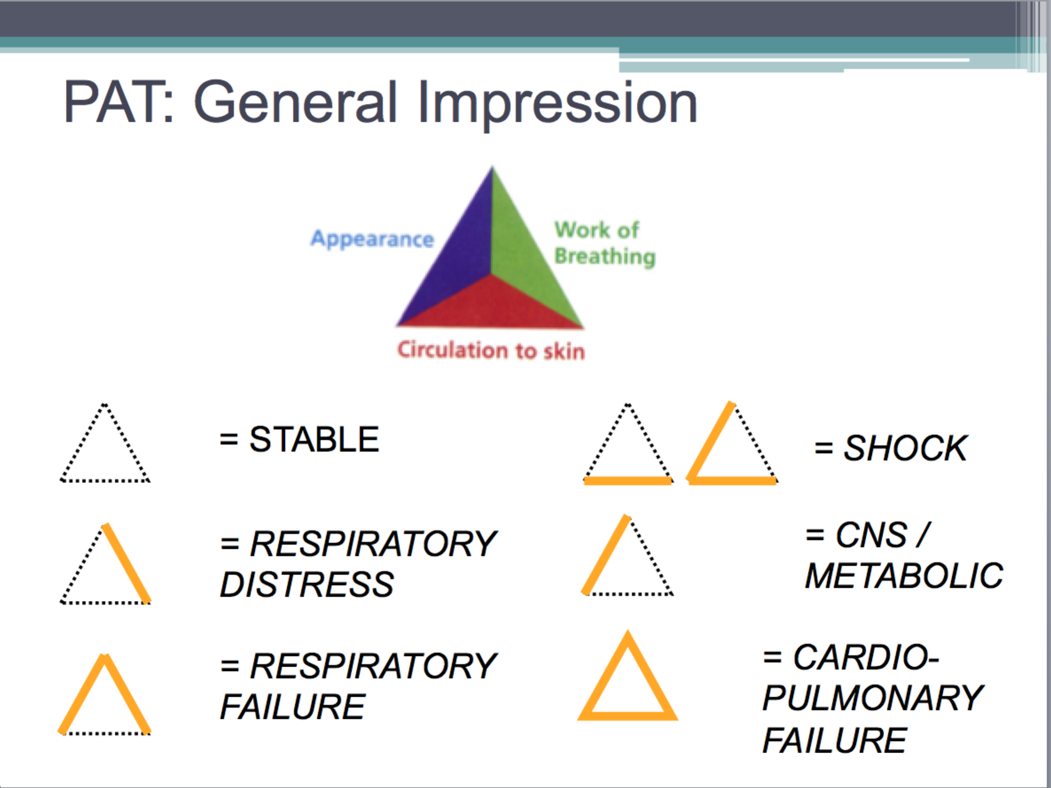

Appearance
“TICLS”
Tone – The newborn should have a normal flexed tone; the 6 month old baby who sits up and controls her head; the toddler cruises around the room.
Interactiveness – Does the 2 month old have a social smile? Is the toddler interested in what is going on in the room?
Consolability – A child who cannot be consoled at some point by his mother is experiencing a medical emergency until proven otherwise.
Look/gaze – Does the child track or fix his gaze on you, or is there the “1000-yard stare”?
Speech/cry – A vigorously crying baby can be a good sign, when consolable – when the cry is high-pitched, blood-curling, or even a soft whimper, something is wrong.
If the child fails any of the TICLS, then his appearance is abnormal.
Work of Breathing
Children are respiratory creatures – they are hypermetabolic – we need to key in on any respiratory embarrassment.

Look for nasal flaring. Uncover the chest and abdomen and look for retractions. Listen – even without a stethoscope – for abnormal airway sounds like grunting or stridor.

Grunting is the child’s last-ditch effort to produce auto-PEEP. Stridor is a sign of critical upper airway narrowing.

Look for abnormal positioning, like tripodding, or head bobbing

Circulation to the skin

Infants and children are vasospastic – they can change their vascular tone quickly, depending on their volume status or environment.

Without even having to touch the child, you can see signs of pallor, cyanosis, or mottling. If any of these is present, this is an abnormal circulation to the skin.

Pattern of Abnormal Arms = Category of Pathophysiology

Differential Diagnosis in a Sick Infant: “THE MISFITS”

Trauma – birth trauma, non-accidental – check for a cephalohematoma which does not cross suture lines and feels like a ballotable balloon, as well as for subgaleal hemorrhage, which is just an amorphous bogginess that represents a dangerous bleed. Do a total body check.

Heart disease or Hypovolemia – is there a history of congenital heart disease? Was there any prenatal care or ultrasound done? Does this child look volume depleted?

Endocrine Emergencies – Could this be congenital adrenal hyperplasia with low sodium, high potassium, and shock? Look for clitoromegaly in girls, or hyperpigmented scrotum in boys. Could this be congenital hypothyroidism with poor tone and poor feeding? Any history of maternal illness or medications? Congenital hyperthyroidism with high output failure?

Metabolic – What electrolyte abnormality could be causing this presentation? Perhaps diGeorge syndrome with hypocalcemia and seizures?

Inborn Errors of Metabolism – there are over 200 inborn errors of metabolism, but only four common metabolic pathways that cause a child to be critically ill. Searching for an inborn error of metabolism is like looking for A UFO – amino acids, uric acids, fatty acids, organic acids. If the child’s ammonia, glucose, ketones, and lactate are all normal in the ED, then his presentation to the ED should not be explained by a decompensation of an inborn error of metabolism.

Seizures – Neonatal seizures can be notoriously subtle – look for little repetitive movements of the arms, called “boxing” or of the legs, called “bicycling”.

Formula problems – Hard times sometimes prompt parents to dilute formula, causing a dangerous hyponatremia, altered mental status, and seizures. Conversely, concentrated formula can cause hypovolemia.

Intestinal disasters – 10% of necrotizing enterocolitis occurs in full-term babies – look for pneumatosis intestinalis on abdominal XR; also think about aganglionic colon or Hirschprung disease; 80% of cases of volvulus occur within the 1st month of life.

Toxins – was there some maternal medication or ingestion? Is there some home remedy or medication used on the baby? Check a glucose ad drug screen.

Sepsis – Saved for last – You’ll almost always treat the sick neonate empirically for sepsis – think of congenital and acquired etiologies.

PEARL: Sepsis is by far the most common cause of a sick infant. However, it is last in the mnemonic on purpose so you consider all other possible causes to make sure you don’t miss anything!

Hyperoxia Test
The hyperoxia test is the single most important initial test in suspected congenital heart disease – we can test the child’s circulation by his reaction to oxygen on an arterial blood gas.

Procedure:
Place the child on a non-rebreather mask, and after several minutes, perform an ABG. (Ideally you obtain a preductal ABG in the right upper extremity, and compare that with one on the lower extremity, but this may not be practical.)

In a normal circulatory system, the pO2 should be high – in the hundreds – and certainly over 250 torr. This effectively excludes congenital heart disease as a factor. If the pO2 on supplemental oxygen is less than 100, then this is extremely predictive of hemodynamically significant congenital heart disease. Between 100 and 250, you have to make a judgement call, and I would side on worst first.

If you are giving this child 100% O2, and he doesn’t improve 100% — that is, his ABG is not at least 100 – then he has congenital heart disease until proven otherwise.

Give prostaglandin if the patient is less than 4 weeks old (typical presentation is within the first 1-2 weeks of life). Start at 0.05 mcg/kg/min. PGE keep the systemic circulation supplied with some mixed venous blood until either surgery or palliation is decided.

Summary Points
- When you see a sick infant, keep THE MISFITS around to keep you out of trouble.

- Before you decide on sepsis, ask yourself, could this be a cardiac problem?

- When in doubt, perform the hyperoxia test.

- All the rest, you have time to look up.

Neonatal Shock Algorithm:

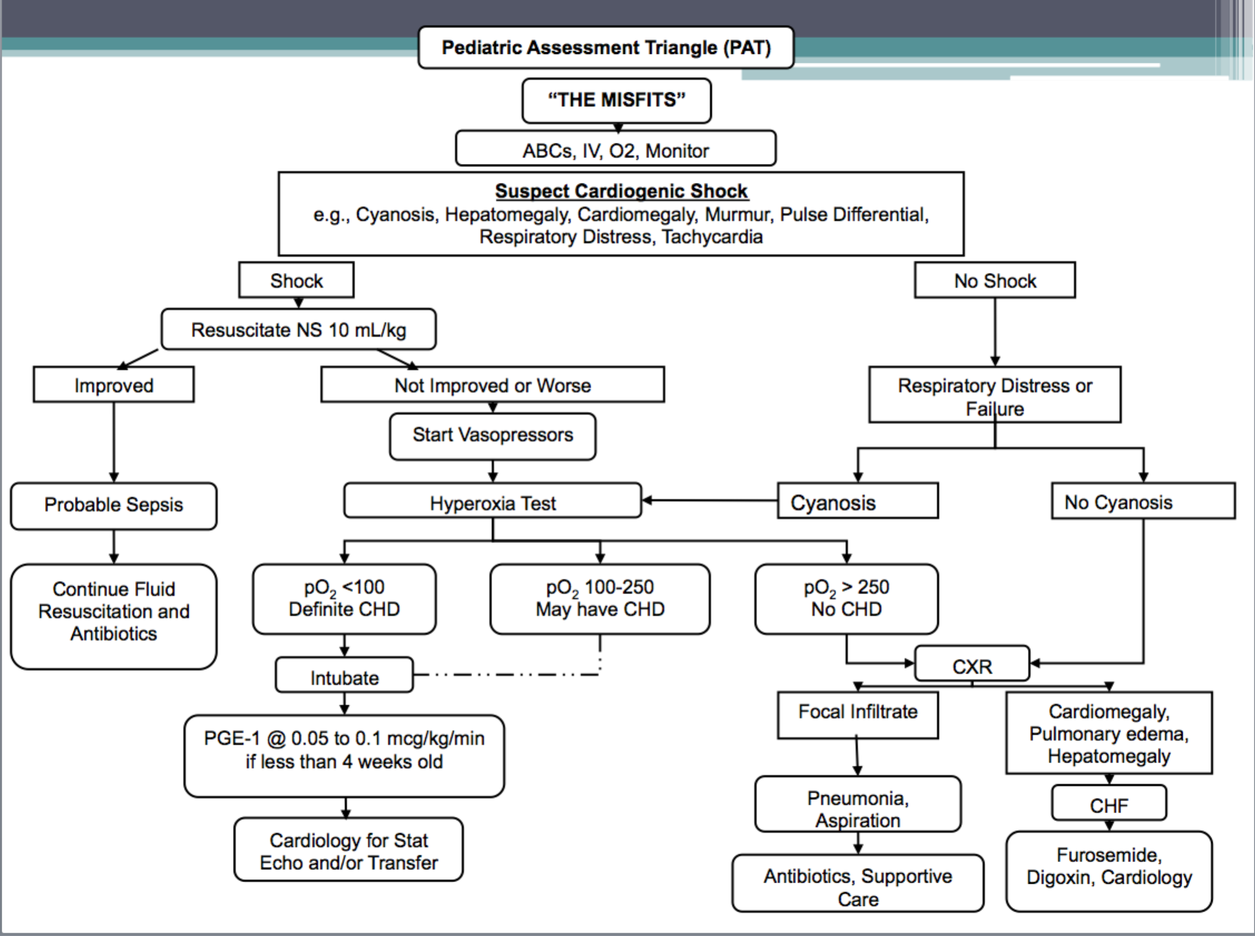

Contact- Tim Horeczko- coach@PEMplaybook.org; Twitter: @EMtogether
steve@embasic.org; Twitter: @embasic

