EM Basic- Acetaminophen (APAP) Overdose
(This document doesn’t reflect the views or opinions of the Department of Defense, the US Army, the US Air Force, the NYIT College of Osteopathic Medicine, or the Fort Hood Post Command©2014 EM Basic LLC, Andrea Sarchi MS IV, Steve Carroll DO. May freely distribute with proper attribution)

Background
Acetaminophen is a component of hundreds of OTC and prescription medications

Mechanism
Therapeutic doses - 90% metabolized in liver by sulfation and glucoronidation to harmless conjugates, then excreted in urine-remaining 10% metabolized by hepatic P450 pathway into NAPQI, which is detoxified by hepatic glutathione
Toxic doses – more APAP down P450 pathwaymore NAPQI and not enough glutathione to keep upliver injury

History
Acute or chronic exposure?
Ask for ALL poisonings:
What did you take?
Dosage – dose per tablet and how many tablets?
TIME of ingestion?
Suicide attempt?
Single ingestion or repeated ones?
Any coingestants?
Any comorbid conditions? (EtOH use, anticonvulsants, Gilbert’s)
EtOH use – chronic use is a risk factors in those who have ingested multiple supratherapeutic doses of APAP
Medications that worsen outcome
CYP inducers – anticonvulsants (carbamezapine, Phenobarbital), anti-TB drugs (INH, rifampin)
Others – TMP-SMX (bactrim), zidovudine, herbal supplements

Pearl – ask the patient if they have taken any other pain medications such as Percocet, vicodin, etc, which also contain APAP

Signs/Symptoms, Physical Exam, and Lab Findings by stage
Vital signs – nonspecific
Stage I (30 min to 24 hrs post-ingestion) – some patients asymptomatic, some have N/V, diaphoresis, lethargy
Labs - Normal LFTs.
Stage II (24 to 72 hrs) – stage I symptoms resolve, pt appears better clinically. As time passes, may develop RUQ pain/tenderness and hepatomegaly
Labs - ↑ PT, ↑ total bilirubin, possible oliguria.
Stage III (72 to 96 hrs) – jaundice, confusion d/t hepatic encephalopathy, cerebral edema, bleeding diathesis, multiorgan failure, possible ARF
Labs – ↑ AST and ALT, often > 10,000 IU/L, hyperammonemia, ↑ PT/INR, hypoglycemia, lactic acidosis, total bilirubin >4.0 mg/dL
Stage IV (begins anytime 4 days to 2 wks post-ingestion) – complete clinical recovery, and eventually complete hepatic histologic recovery

Workup
Serum APAP concentration – obtain 4 hrs after ingestion or ASAP if ingestion was > 4 hrs ago
BMP (electrolyte, glucose, renal function)
ABG/VBG (APAP ingestion and hepatic failure can lead to acidosis)
Coags, LFTs, Ammonia level (signs of hepatotoxicity)
CBC (baseline)
Urine hCG (women of childbearing age)
ECG, ETOH, and ASA level (coingestions)

PEARL – in patients with chronic APAP ingestion who have any signs/symptoms of hepatotoxicty, order a serum APAP concentration and AST regardless of when the ingestion occurred (risk of hepatoxicity greater in chronic ingestion than for a single, acute OD)

Management
ABCs
O2 and fluids as necessary
Cardiac monitor (coingestions)
Activated Charcoal – 1g/kg up to 50 g PO within 4 hrs of ingestion
N-acetylcysteine (NAC)
Indications
Serum APAP concentration above tx line on nomogram (Fig. 1)
Single APAP ingestion > 150 mg/kg or 7.5 g total in a patient for whom we can’t obtain an APAP concentration until >8 hrs post-ingestion
Patient with unknown time of ingestion and serum APAP > 10mcg/mL
Patient with hx APAP ingestion and ANY evidence of liver injury
Patients who present > 24 hrs post-ingestion with lab signs of liver injury
PEARL – the nomogram is the most important way to determine the need for NAC therapy in an acute APAP OD
72-hour PO protocol – loading dose 140 mg/kg PO, then 70 mg/kg PO every 4 hrs for 17 total doses
21-hour IV protocol – loading dose 150 mg/kg over 1 hr, then 4-hr infusion of 12.5mg/kg/hr, then 16-hr infusion at 6.25 mg/kg/hr
PEARL – NAC is safe and effective in pregnant women. Crosses the placenta and thus IV form preferred.

Disposition
Patient treated with NACadmitted
Patient asymptomatic/mild symptomsadmit to medicine or obs unit
Patient had evidence severe heaptotoxicity/hepatic failureadmit to medical ICU

PEARL – consult a medical toxicologist/regional poison control center as needed and obtain a psychiatric consult for intentional overdoses

(Contact: steve@embasic.org)
Figure 1
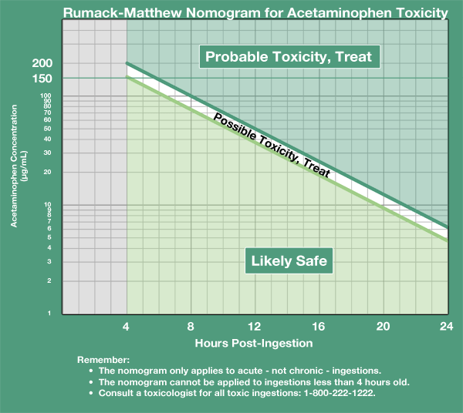
http://www.mdcalc.com/acetaminophen-overdose-and-iv-nac-dosing/

