EM Basic- Pulmonary Embolism Part 2- Risk Stratification and Treatment
(This document doesn’t reflect the views or opinions of the Department of Defense, the US Army, or the Fort Hood Post Command © 2014 EM Basic LLC, Steve Carroll DO. May freely distribute with proper attribution)

Risk stratification of PE

Non-massive- “regular/small PE” (non-massive not used a lot in the literature/textbooks but I think it works)
-PE without any hypotension/hemodynamic instability or signs of right heart strain

Sub-massive PE- A PE with signs of right heart strain WITHOUT hypotension/hemodynamic instability

-Signs of Right Heart Strain
-Increased troponin or brain naturetic peptide (BNP)
-Signs of right heart strain on bedside echo
-Increased ventricular size (RV:LV ration 0.9 or higher)
-Bowing of the intraventricular septum into the LV

Massive PE- a PE with hypotension (systolic BP <90) or cardiac arrest

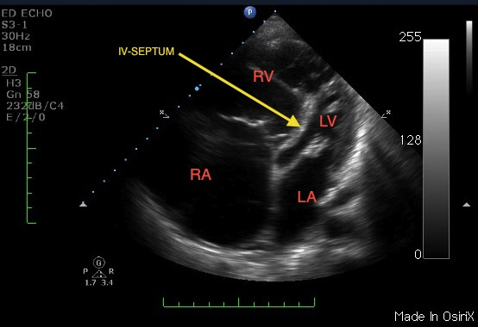

Bowing of intraventricular septum and increased RV size
(Credit: http://emoryeus.blogspot.com/2012/02/right-heart-strain.html)

Treatment of PE

Non-massive- anticoagulation

-Most common- enoxaparin (Lovenox) 1mg/kg SQ BID or 1.5 mg/kg daily (less common fondaparinaux (Arixtra))

PEARL: I prefer daily dosing in case patient has a bleeding complication after admission

-Warfarin (Coumadin)- have the inpatient team start after Lovenox

PEARL: If you start Coumadin first, can make patient transiently hypercoagulable, it also takes days to weeks to get therapeutic anticoagulation (Lovenox is pretty much immediate)

Inpatient vs. outpatient- standard practice is to admit all patients with PE for monitoring and starting anticoagulation as an inpatient. Newer literature suggests that you may be able to manage non-massive PEs as outpatients with Lovenox/Coumadin or newer oral anticoagulants- this needs institutional support/protocols and primary care coordination

Sub-massive PEs- anticoagulation

-Heparin drip- can turn infusion off if patient gets worse and needs thrombolytics

-80 units/kg IV as a bolus then 18 units/kg/hr as a drip

-Thrombolytics?- older studies did not show mortality benefit but having a large clot in your lungs for a long time can lead to pulmonary hypertension that can make patients into pulmonary cripples

-MOPPET trial- half-dose TPA (alteplase) vs. placebo- no difference in mortality, 41% absolute risk reduction in pulmonary HTN at 6 months

-PIETHO trial- full dose TPA vs. placebo- no difference in mortality, decreased risk of cardiovascular collapse within first 7 days- higher mortality in those over 75 years old

Thrombolytics for sub-massive PE bottom line:- Half dose thrombolytics in those with sub-massive PE who are young and healthy with good functional status and no risk factors for increased bleeding (usual TPA contraindications) is probably a good idea and something you should offer to the patient

PEARL: Patients with sub-massive PE should probably go to the ICU or at least step-down with thrombolytics at their beside in case they decompensate

Massive PE- PE with hypotension (even if transient) or cardiac arrest

-In cardiac arrest- no consensus on an accepted dosing regiment- 50-100mg TPA bolus IV +/- infusion- probably best to just do 100mg TPA slow IV push over 1 minute

-Not in cardiac arrest- stop heparin drip (if started) and give TPA 100mg- 10mg IV as a bolus over 1 minute, other 90mg IV over 2 hours

Anticoagulation before CT

-Low risk for PE- don’t need anticoagulation before CT if you can get CT in reasonable amount of time

-Medium risk for PE- AHA says it should be considered but probably not needed if you can get CT in a reasonable amount of time- these patients have a risk of PE that’s probably less than 50% and heparin/lovenox won’t start to dissolve clot (only prevents clot extension/growth)

-High risk for PE and unstable- start heparin prior to CT and bring thrombolytics to the scanner as you accompany the patient, may even need to start thrombolytics prior to CT if patient is very unstable- especially if signs of right heart strain on echo.

Contact- steve@embasic.org Twitter- @embasic

