EM Basic- Hyperkalemia
(This document doesn’t reflect the views or opinions of the Department of Defense, the US Army, or the Fort Hood Post command © 2012 EM Basic, Steve Carroll DO. May freely distribute with proper attribution)

Hyperkalemia- high serum potassium
- #1 cause = pseudohyperkalemia
-Due to hemolysis of blood sample
-RBCs hit wall of blood tube and lyse
-This falsely elevates potassium level
PEARL- ALWAYS check hemolysis level before acting on a potassium level. BUT take it in clinical context- a potassium of 5.2 (upper limit of normal 5) with 2+ hemolysis not worrisome, potassium of 8 with 1+ hemolysis is very worrisome

First step- Check the patient to ensure stability (ABCs, neuro status)

Next step- get a STAT EKG
-Look for EKG changes
-First sign- peaked T waves
-Progression to widened QRS
-Highest potassium level- sine wave

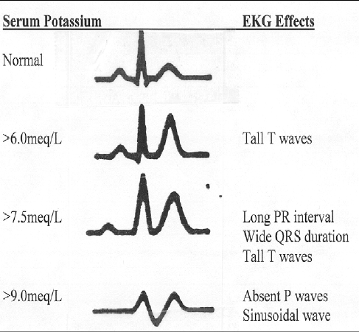

PEARL- Only 20-30% of patients with serious hyperkalemia will have EKG changes. Although the graphic says it- can’t accurately predict potassium level based solely on the EKG

Symptoms of Hyperkalemia
-Can be non-specific
-Nausea, vomiting, weakness, fatigue, altered mental status

Causes of Hyperkalemia
-Most of the time- renal failure
-Medications- spironolactone, beta blockers, cyclosporine, insulin
deficiency (mostly in DKA), crush injuries (rhabdo)

Treatment of hyperkalemia

Mnemonic- C BIG K DIE Mechanism

Calcium Stabilizes cardiac membrane

β-agonists/Bicarb Pushes K into the cell
Insulin SAME
Glucose SAME

Kayexalate (polystyrene sulfonate) Eliminates from the body (causes diarrhea)

DIE- Dialysis Eliminates from the body

Calcium
-Calcium gluconate- start with 3 amps IV
-Calcium chloride- 3 times more calcium, should be given through central line or good peripheral (18 gague AC, NOT a small hand vein)
-Mechanism- stabilizes the cardiac membrane, prevents cardiac arrest from hyperkalemia

PEARL- Calcium is the most important treatment to give up front & quickly to critically ill patients, most say that you should have EKG changes but calcium is very safe to give

PEARL- Mostly debunked but theoretical risk of causing “stone heart” when calcium given to patients with digitalis toxicity. Can’t be faulted for giving calcium if you didn’t know patient was on dig, if you know they are on dig then document thoroughly that pt was sick & needed calcium. Can reverse with digibind if needed (dig antibody)

β-agonists- Albuterol neb- one hour neb will bring potassium down approximately 0.5 meq- no IV access required

Mechanism- Drives potassium into the cells

Bicarb- only truly works if the patient is acidotic- DO NOT give in patients with DKA unless they are really sick- fixing their DKA will drive down their potassium

Mechanism- Drives potassium into the cells (if acidotic)

Insulin/Glucose- 10 units of regular insulin IV with one amp of glucose (D50)- check blood sugar first before giving glucose. May not need insulin in patient without diabetes or a patient with high blood sugar but little harm in giving both insulin/glucose

Mechanism- Drives potassium into the cells (insulin required to bring glucose into the cell)

Kayexalate (polystyrene sulfonate)- binding resin that supposedly binds potassium but more likely mechanism is causing diarrhea- not a lot of evidence that it works and can cause harm & can take hours to work. Dose- 15 grams PO or 30 grams PR

Mechanism- Eliminates potassium from the body (via diarrhea)

Lasix (furosemide)- lasix kind of sounds like lasik if you use your imagination- loop diuretic that causes potassium to be excreted into the urine, takes hours to work. Can worsen kidney function- use caution unless already actively on dialysis

Dose- 30 mg IV or daily PO dose as an IV dose

Mechanism- eliminates potassium via urine

Dialysis- the last step in any patient with severe hyperkalemia, especially useful if patient is already on dialysis- do all the other treatments first you are waiting on nephrology to dialyze

If mild hyperkalemia (6.0 without EKG changes) can start with a beta agonist neb & some insulin/glucose- don’t have to throw kitchen sink at the patient unless they are super sick

Contact- steve@embasic.org Twitter- @embasic

