EM Basic- Syncope
(This document doesn’t reflect the views or opinions of the Department of Defense, the US Army or the SAUSHEC EM residency, © 2011 EM Basic, Steve Carroll DO. May freely distribute with proper attribution)

Definition of syncope- a rapid loss of consciousness followed by a rapid return to baseline
-Pure syncope- usually cardiac in nature- rapid loss of bloodflow to the brain
-Vasovagal syncope- stressor causes increased vagal tone that causes bradycardia and hypotension -> syncope

(if the patient has other symptoms like chest pain or headache, is confused after awakening or is unconscious for an extended period of time- that is not pure syncope and demands a different workup)

History- it’s all about the history for this chief complaint

PEARL- Dizzy does not equal syncope!
Dizziness- sense of the room spinning or loss of balance (disequilibrium)= different workup than syncope workup
-Ask the patient: “Was the room spinning or did you feel like you
were going to pass out?” (Spinning= dizziness, pass out= syncope)

PEARL- Near syncope (or lightheadedness) is the same as Syncope (in regards to the workup)

Stressors- try to identify preceding stressors- dehydration, emotional distress, rapid temperature changes, painful condition, insufficient food or water intake

Symptoms- prodrome of feeling flushed and hot, tingling in extremities, nausea = more suggestive of vasovagal syncope

Activity- what was the patient doing? Were they exercising at the time of collapse (VERY IMPORTANT!)

Witnesses- ask them if the patient hit their head, any seizure activity (more than a few muscle jerks?), how long until the patient woke up, any confusion after waking up?
PEARL- to diagnose a seizure there has to be sustained generalized tonic/clonic movements followed by a period of post-ictal confusion

Preceding symptoms and red flags

Syncope + headache= subarachnoid or intracranial hemorrhage
Syncope + neuro deficit= stroke/TIA or intracranial bleed
Syncope + confusion= seizure
Syncope + chest pain= MI, PE, or aortic dissection
Syncope + back/abdominal pain in older patient= abdominal aortic aneurysm (AAA)
Syncope + positive HCG= ectopic pregnancy

Past medical history- is this recurrent syncope or is this new? Ask for history of seizures, MI, stroke/TIA, known AAA, family history of heart disease

PEARL- In younger patients say “I’m not saying this is going to happen to you but did anyone in your family die suddenly and they couldn’t find out why?” (Screen for inherited arrhythmias/cardiomyopathy)

Physical exam- check for head trauma, do a good neuro exam, listen for murmurs (both with valsalva and with standing and squatting in younger patients), abdominal/back tenderness

Differential diagnosis (with triggers)

Seizure- sustained generalized tonic/clonic movements with eyes open with post-ictal confusion

Subarachnoid/intracranial hemorrhage- syncope plus a headache or a neuro deficit

Ruptured AAA- older patient with hypertension with back/abdominal pain or hematuria +/- unstable vital signs- stat bedside ultrasound
Stroke/TIA- syncope with neuro deficit

GI Bleed- syncope plus black or bloody stools

MI/ACS- chest pain and syncope

Aortic dissection- sudden onset of ripping or tearing chest/back pain +/- pulse or neuro deficit

Aortic stenosis- older patient with a systolic ejection murmur that radiates into the carotids

Pulmonary embolism- sudden onset of dyspnea/pleuritic chest pain +/- risk factors for PE

Arrhythmia- see below- WPW/HOCM/Long QT/Brugada

Carotid sinus sensitivity- syncope with activities that put pressure on carotid sinus (tying a necktie, shaving, checking carotid pulse)

Orthostatic hypotension- medications such as alpha and beta blockers, dehydration

Hypoglyemica- diabetic patient or ingestion of diabetic medications

Tox- drugs, ETOH, environmental (carbon monoxide)- look for a toxidrome

Sepsis- fever and signs of infection

Syncope Workup- EKG and an HCG in females are a MUST- other testing guided by clinical picture
PEARL- Troponins and head CTs are positive only 0.5% of the time and in all cases were suggested by the history (chest pain, neuro deficit, etc.)

PEARL- In general- young patients with a normal EKG/negative HCG and no red flags go home, older patients- admitted for tele monitoring

Labs (if necessary, usually for older patients who are being admitted)

D-stick (some clinicians do this in all patients)
CBC- (severe anemia can cause syncope)
Chem 10- (electrolyte abnormalities can cause arrhythmias)
UA- UTIs can cause a wide variety of symptoms in older patients
Non-contrast head CT- if there is head trauma +/- C-spine CT as needed

EKG findings in syncope- look for these 4 findings on EVERY EKG on a patient with syncope- Long QT, Brugada, WPW, HOCM/LVH
Pneumonic- BLOW Hard- (Brugada, LOng QT, WPW, HOCM)

Long QT syndrome- congenital disorder causing prolonging of refractory period = greater chance of R on T phenomenon (PVC on downslope of T wave causing v-fib).

EKG- Long QT defined as >440 milliseconds in males, >460 ms in females (some experts say QTs >500 are most concerning)

PEARL- to eyeball a normal QT- T wave is within the first half of the R to R interval, look for U wave that may cause EKG machine to overcall the QT interval

Dispo- no exercise until evaluated and cleared by cardiology, give seizure precautions (no driving, no swimming, shower with a chair or with someone nearby)

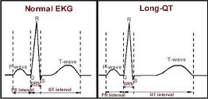

Wolf Parkinson White (WPW)- accessory pathway that bypasses AV node and can cause V-tach
EKG- shortened PR and delta wave (slurring of Q to R transition)-
Dispo- needs Cardiology/EP followup, no exercise until cleared by cardiology

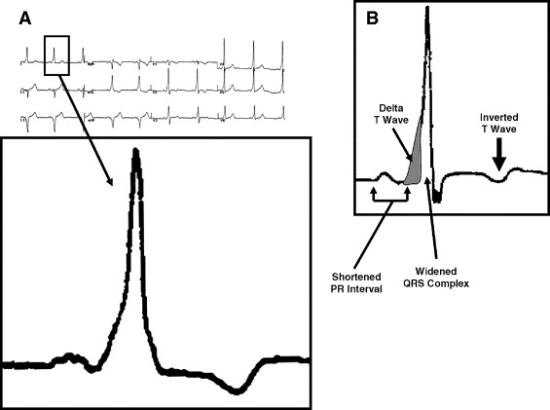

Brugada syndrome- sodium channel disorder- frequent syncope in a young and otherwise healthy patient without heart disease with a right bundle block pattern and ST elevation in V1-V3
Dispo- admit for immediate implanted defibrillator placement (high risk for sudden death)
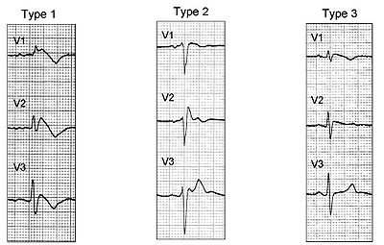
Hypertrophic cardiomyopathy/LVH- thickened LV wall that causes outflow obstruction with exercise, classically a young athlete that collapses during exercise
EKG- LVH (tall R waves in V4-V6 or AVL and deep Q waves in V4-V6)
Dispo- confirm with echo + no exercise until cleared by cardiology

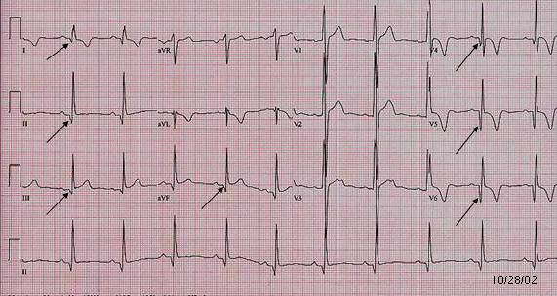

Overall dispo for syncope

Young patients- normal EKG/negative HCG, no red flags, and normal EKG= discharge
Older patients (50 or over- my opinion, definitely over 65)- admitted for telemetry monitoring and further workup

San Francisco Syncope rule- insufficient sensitivity to rule out need for admission (52-92% sensitivity for serious outcomes in validation studies) if positive, more reason to admit

CHF- History of CHF or current suspicion
Hematocrit <30%
EKG abnormalities (non-sinus rhythm or change in EKG)*
Shortness of breath (with syncope episode)
Systolic BP less than 90 after arrival to the ED

*Although this was excluded in the original study, most clinicians also include any T wave abnormalities in the “abnormal EKG” criteria

Big points
1) Syncope= rapid loss of consciousness followed by rapid return to baseline- period, anything else demands a bigger workup
2) Syncope workup must include EKG and HCG in females, everything else dictated by clinical scenario
3) Syncope with exercise= red flag- look for WPW, Long QT, Brugada, and HOCM in young patients
4) Young patients with syncope with no red flags and negative EKG/HCG go home, older patients get admitted for further workup
Contact- steve@embasic.org Twitter- @embasic

